**Design Document**

**Filament Recycler**

Group Members: Alec Rich, Connor Cassaro, Jon Bayert,

Paul Oscar Benbow, Munib Rashad, and Nicole Pomeroy

Primary Advisor: Dr. Daniel Blood

Secondary Advisor: Dr. Sami Khorbotly

Course: GE-498

Valparaiso University

Report Submitted on May 04, 2021

**Honor Code Statement**

I have neither given or received, nor have I tolerated other’s use of unauthorized aid.

Connor Cassaro Munib Rashad

Connor Cassaro Munib Rashad

Nicole Pomeroy Jon Bayert

Nicole Pomeroy Jon Bayert

Alec Rich  *Paul Oscar Benbow*

Alec Rich Oscar Benbow

**Finalized System Design Requirements:**

The system design requirements document (SDRD) was a document that was created at the beginning of the project that included the desires of the customer and other requirements that needed to be met. This specified what needed to be done for the electrical system, mechanical system, extrusion of the filament, safety, user interface, budget, and documentation by the completion of the project.

1. Electrical Systems
   1. The system shall be able to use an input between 95-125 VAC or 195-255 VAC at 60Hz.
2. Mechanical System
   1. The system shall fit in a cuboid with dimensions of 82 inches by 50 inches by 46 inches.
   2. The system shall have an in-house sensor to measure the output filament diameter.
3. Filament
   1. The barrel nozzle shall maintain a temperature accuracy of ± 2.5 degrees Celsius from the set value.
   2. The output filament diameter shall be 1.75 ± 0.05 mm.
   3. The filament shall be extruded onto a nominally 1 kg spool.
   4. The system shall accept shredded plastic with no dimension exceeding 7 mm.
   5. The system shall be capable of extrusion at a rate of at least 0.2 kg per hour.
4. Safety

4.1. The system shall cut off power within 1 second of using the emergency stop.

4.2. The system’s mechanical components shall stop within 5 seconds of using the emergency stop.

4.3. The system shall be built such that external surfaces that can be touched will not exceed temperatures of 49 degrees Celsius.

4.4. Any opening of the system shall comply with Table O-10 of OSHA 29 CFR 1910.217(c)(2)(i)(a) and 1910.217(c)(2)(i)(b).

1. User Interface
   1. The system shall maintain storage specified settings even after power loss.
   2. The system shall allow for manual temperature control between 130 and 180 degrees Celsius.
   3. The system shall allow for manual flow rate control between 0.1 kg and 0.2 kg per hour.
   4. The system shall display the current temperatures of the nozzle.
2. Budget
   1. The budget shall not exceed $5,000.
3. Documentation
   1. A bill of materials shall be included in the documentation.
   2. Mechanical drawings shall be included in the documentation.
   3. Electrical schematics shall be included in the documentation.
   4. Wiring diagrams shall be included in the documentation.
   5. Source code shall be included in the documentation.

**Complete Parts List:**

The parts list contains every component that was purchased or manufactured for the project. This is so that if anyone wants to recreate the project they can refer to this list to purchase everything that was utilized. It contains the manufacturer, supplier, count, and costs.

https://docs.google.com/spreadsheets/d/1WxjAF2HjHVjLTZQiJ8RRIu_GC2DpGSwYj-QV17-FsrE/edit?usp=sharing

**Detailed Drawings:**

The drawings are for anyone that would like to manufacture the parts that were made for this project. This includes parts that were manufactured outside of the team such as the barrel.

|  |
| --- |
|  |
| **Figure 1.** Hopper |

|  |
| --- |
|  |
| **Figure 2.** Coupler Keyed Rod |

|  |
| --- |
|  |
| **Figure 3.** Barrel |

|  |
| --- |
|  |
| **Figure 4.** Flange |

|  |
| --- |
|  |
| **Figure 5.** Fan Mount |

|  |
| --- |
|  |
| **Figure 6.** Nozzle Cap |

|  |
| --- |
|  |
| **Figure 7.** Barrel Supports |

|  |
| --- |
|  |
| **Figure 8.** Angle Irons |

|  |
| --- |
|  |
| **Figure 9.** Back Support |

|  |
| --- |
|  |
| **Figure 10.** Front Support |

|  |
| --- |
|  |
| **Figure 11.** Diameter Sensor Housing. This design was inspired from a DIY project which you can find here: https://www.thingiverse.com/thing:4551806 |

|  |
| --- |
|  |
| **Figure 12.** Diameter Sensor Arm |

|  |
| --- |
|  |
| **Figure 13.** Channel Support |

|  |
| --- |
|  |
| **Figure 14.** Slack Sensor |

|  |
| --- |
|  |
| **Figure 15.** Spool Holder |

|  |
| --- |
|  |
| **Figure 16.** Spool Base |

|  |
| --- |
|  |
| **Figure 17.** Spool Tower |

**Assembly Drawings:**

The assembly drawings are to illustrate how each part fits together to make a whole component to the system. This will include individual assemblies and the final assembly with everything on it.

|  |
| --- |
|  |
| **Figure 18.** Extrusion Base Assembly |

|  |
| --- |
|  |
| **Figure 19.** Barrel Assembly |

|  |
| --- |
|  |
| **Figure 20.** Extrusion System Assembly |

|  |
| --- |
|  |
| **Figure 21.** Diameter Sensor Assembly |

|  |
| --- |
|  |
| **Figure 22.** Spooling Assembly |

|  |
| --- |
|  |
| **Figure 23.** Back End Assembly |

|  |
| --- |
|  |
| **Figure 24.** Filament Extruder Full Assembly |

**Flow Chart for Control Algorithm:**

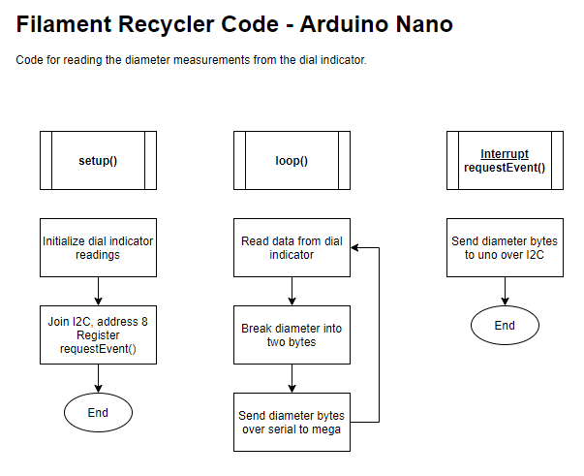

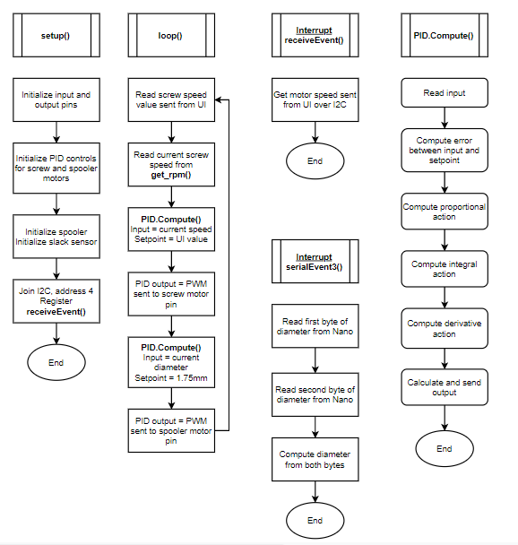

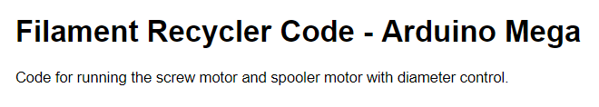

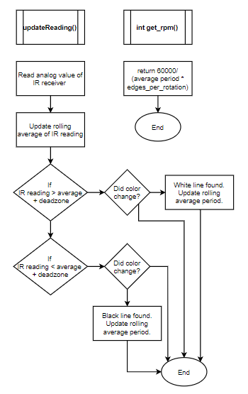

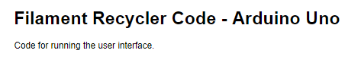

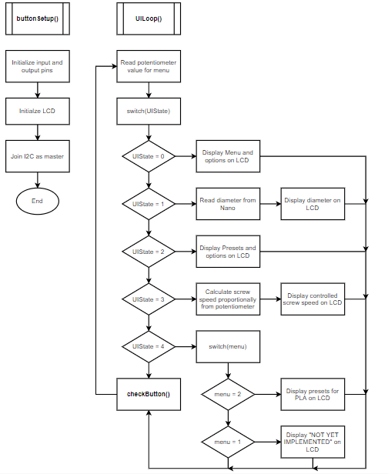

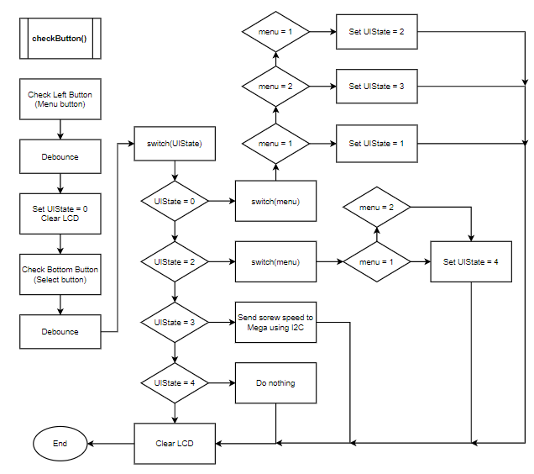

**Computer Code:**

The code is set up to run on three different arduino microcontrollers; one mega, one nano, and one uno. The arduino uno runs the code for the user interface and interacts with the LCD. From the UI, users will be able to view the diameter of the filament as it extrudes, and can adjust the speed of the screw. The arduino nano solely runs the code for reading the filament diameter measurements from the dial indicator due to timing issues. The arduino mega runs the bulk of the control code, including two PID control loops. The first control loop reads the desired speed sent from the UI, compares it to the current screw speed read from the tachometer, and makes adjustments accordingly. The second PID loop monitors the diameter measurement sent from the arduino nano, compares it to the desired diameter (nominally 1.75±0.05mm), and will adjust the speed of the spooler motor, which applies tension to the filament to adjust its diameter.

Full code can be found here:

<https://github.com/jbayert/ValpoFilamentRecyclerCode>

**Electrical Circuit Diagrams:**

The electrical schematics can also be found at:

<https://github.com/jbayert/ValpoFilamentRecycler09>

**RPM Tachometer**

The goal of the RPM Sensor is to detect how fast the screw barrel is turning. There are white and black lines around the barrel. The sensor bounces IR light off the screw motor and detects the lines and computes the average RPM. The Sensor is set up as follows.

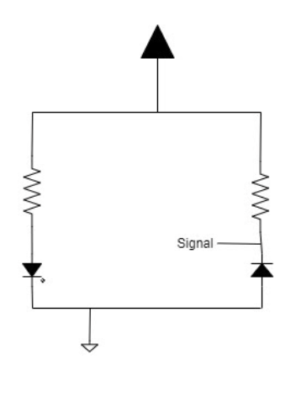

**Heater Coil**

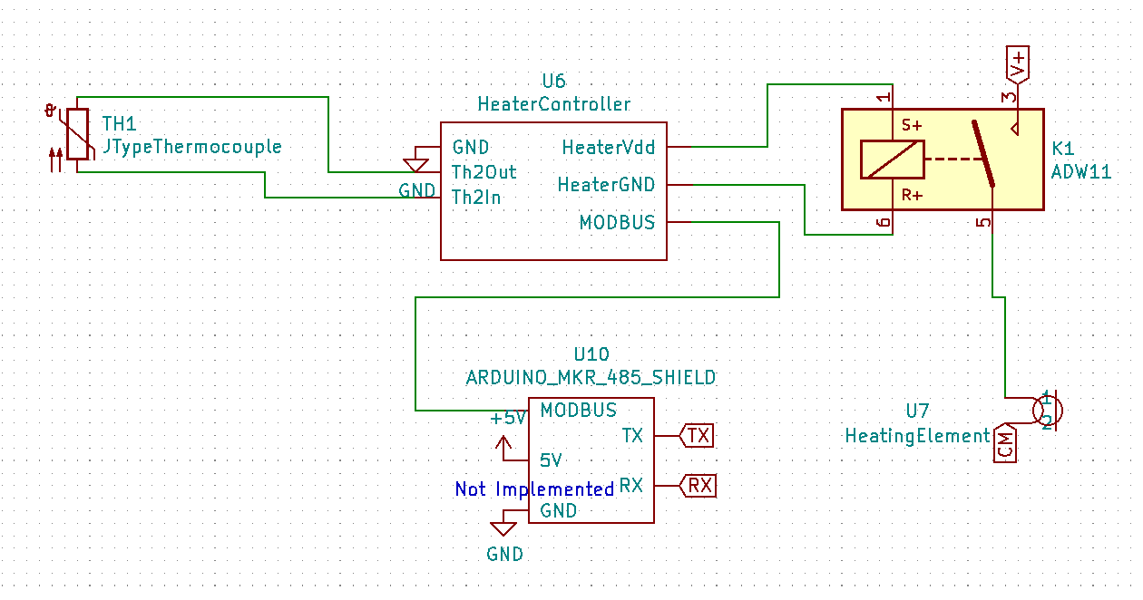

**Screw Motor**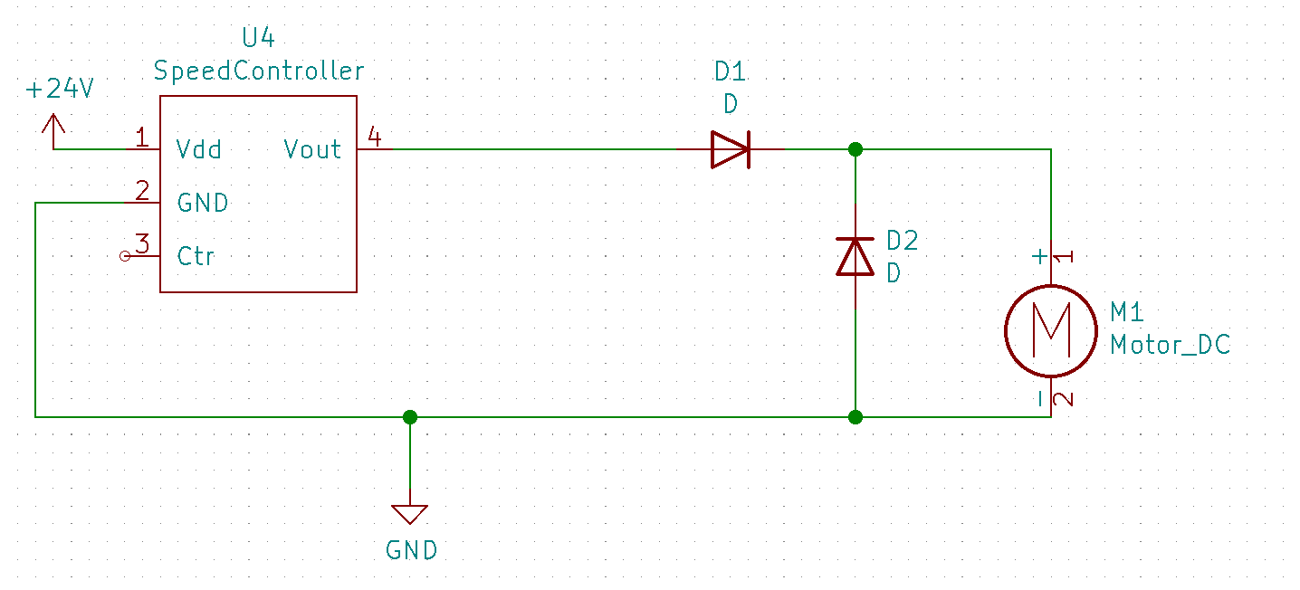

**Power Supply**

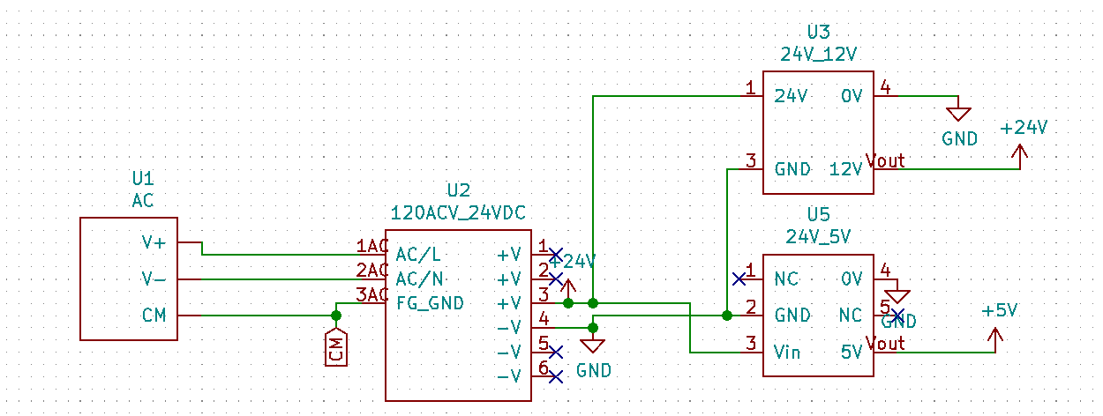

**Spooler Motor**

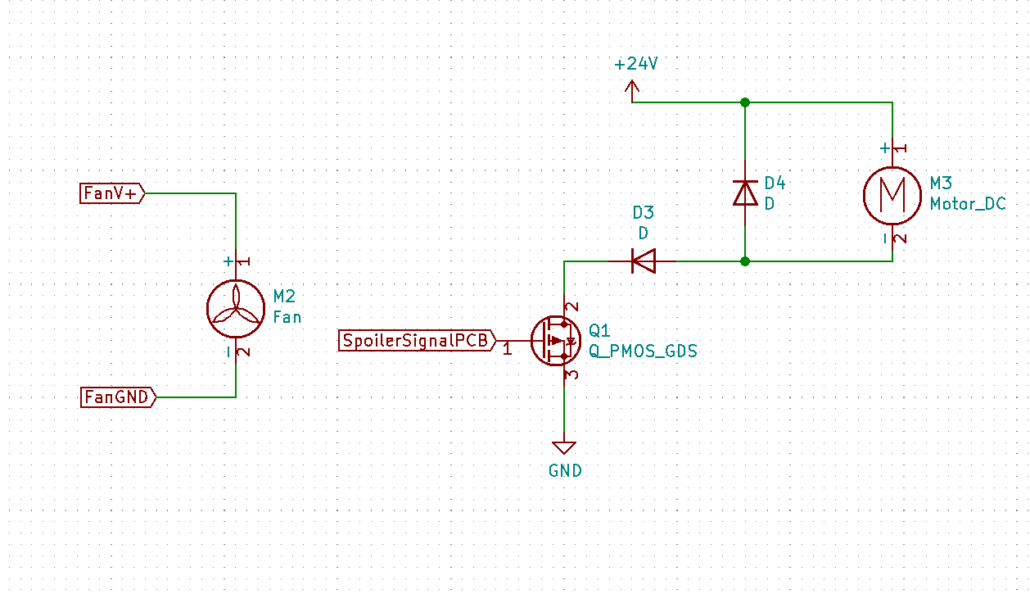

**Controller PCB**

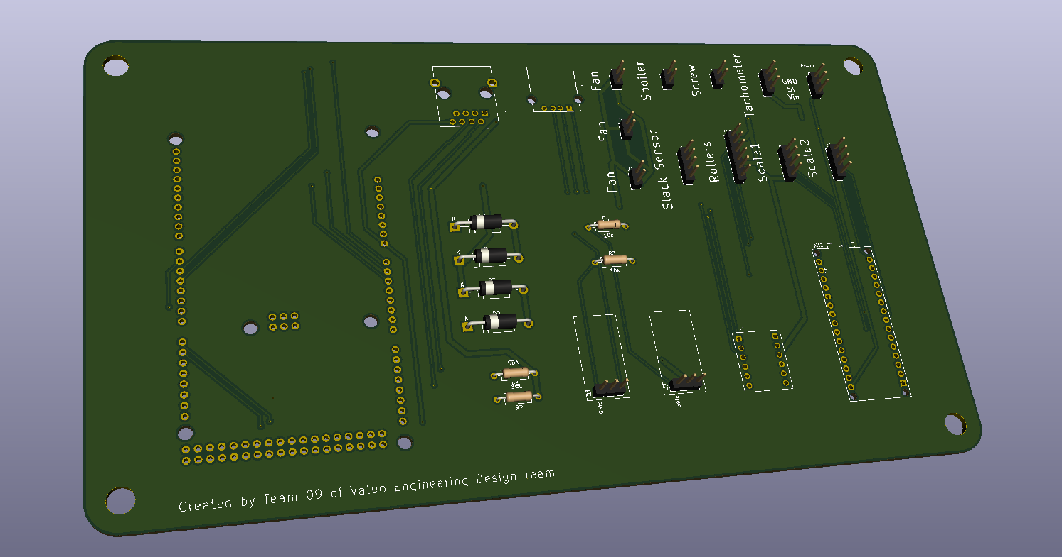

**For detailed information see:**

[**https://github.com/jbayert/ValpoFilamentRecycler09/blob/main/ControllerPCB/ControllerPCB.pdf**](https://github.com/jbayert/ValpoFilamentRecycler09/blob/main/ControllerPCB/ControllerPCB.pdf)

**UI PCB**

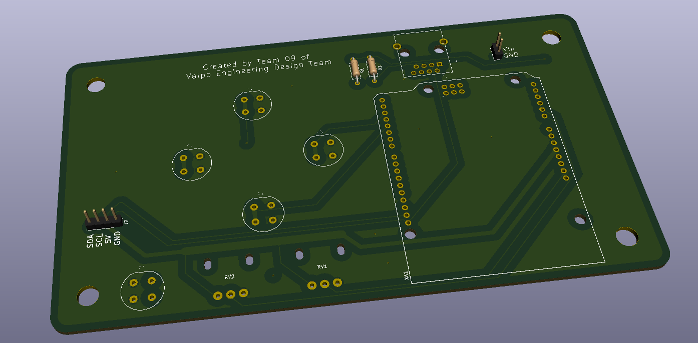

**For detailed information see:**

[**https://github.com/jbayert/ValpoFilamentRecycler09/blob/main/UIpcb/UIpcb%20print.pdf**](https://github.com/jbayert/ValpoFilamentRecycler09/blob/main/UIpcb/UIpcb%20print.pdf)

**Frequently Asked Questions:**

The frequently asked question is for answers to the typical questions that get asked about the project. This is so the main questions are available to those with the answers to said questions.

What temperature works best for extruding the PLA?

* The barrel should be set to 200 ℃ and the nozzle at 190 ℃

Can the system run once the barrel and nozzle hit the desired temperature?

* The system should be allowed to sit for about 10 minutes once the temperature controllers read the desired temperature since the thermocouple will heat up faster than the entire barrel.

Is the system adjustable?

* Yes, the user can set whatever temperature, screw speed, and spooling speed they would like. In addition, the locations of the fans, diameter sensor, and spooler can be easily adjusted by the user as well.

Can the system extrude other materials besides PLA?

* The system was built with components in mind to allow for PETG to be extruded, though the preferred temperatures would need to be determined by the user.

What is the flow rate for the extrusion system?

* With the presets of PLA the system would extrude at 0.5 kg per hour.

What is the best way to calibrate the diameter sensor?

* A gage pin was used by putting it between the two bearings in the diameter sensor housing and the dial indicator should be zeroed with the gage pin in. This allows for the user to see how close to tolerance the filament is.

**Warnings for User:**

The warnings are for concerns with the system and user safety. This should be read and followed before use of the system. This portion also informs the user of what to be cautious of with the environment the project is used in.

* The nozzle is not covered in insulation and will be at temperatures close to 200 ℃.
* If the hopper mesh is not on the hopper while in use, unwanted material or foreign objects may fall in causing a jam or injury.
* Ensure that the ground wire is connected to the support angle iron before turning the system on.
* Shut off power to the system before connecting or disconnecting any components such as the screw motor, fans, or spooler motor so as to not damage the components.

**Limitations:**

The limitations are to let the user know what our system is capable of. This should also inform the user how to properly use the system so as to not damage the system.

* The screw speed cannot exceed 12 rpm.
* System can currently only be powered at 120 VAC.
* After the nozzle and barrel reach desired temperature, the system should be allowed to sit for about 10 minutes at that temperature since the thermocouple will heat up faster than the entire barrel.

**Deviations from finalized SDRD:**

The deviations from the SDRD are the design requirements that were established at the start of the semester that were not able to be met. These deviations have been considered ok to deal with as they do not impede the use of the system under typical conditions.

1. Electrical System

1.1. The system is only able to use an input between 95-125 VAC at 60Hz.

1. Filament

3.2. The output filament diameter is not consistently maintained at 1.75 ± 0.05 mm.

1. Safety

4.3. The nozzle external surfaces that can be touched exceeds temperatures of 49 degrees Celsius.

**Troubleshooting:**

Troubleshooting is for common issues that came up in testing and how the team went about solving the issues. These are the issues that the team feels will be the most common should there be any issues with the system.

* If the screw starts to back out excessively stop the system and either take off the nozzle and let it run to allow the blockage to be removed. Another option is to reverse the connection on the motor via the connectors so that it can be run in reverse.
* If a component is not changing speed when changing the input check the power or connections to the MOSFET located on the top wall of the electrical box.
* If the system is not running properly shut it off and check the connections to the components in question through the electrical box.